* **Lab Task 3**

Insert Network Operations department located in Africa

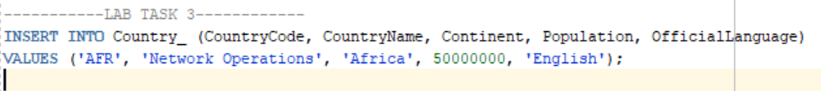

OUTPUT: